AP ASSIGNMENT 1: OSS

# NAME: MUHAMMAD USAMA CLASS: CS-7A REG. 237752

# **Introduction:**

As an editor, I often use a lot different programs for different aspects of editing, one such program is **Audacity**. An open source audio-mixing software.

It has an abundance of delicate and intricate options that are on par with a lot of paid software. Ranging from basic to advanced, for all levels of users.

# **Exploration:**

You have the basic file I/O options like importing and exporting.   
Cutting, Copying and pasting sections of the audio as well as the option to label them. You can save a lot of these as preferences.  
Then come the more advanced options such as real time recording, mixing, muting and even generating(different audio effects) on audio tracks.  
On the management side, you’ve got the options to check for updates, Adding and Removing external plugins and checking the user manual.

There is a lot of visual information that the main edit screen offers you.  
It has hotkeys, Shortcuts and minute details whose data you can manipulate and a timeline of the project, making things easier for the user and saving a lot of time.

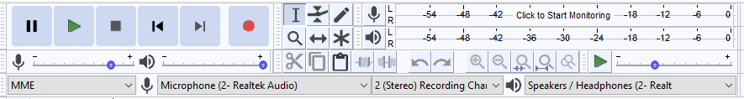



# **Structure:**

All tracks, labels, gain & pan data, amplitude, envelope points is stored along with the rest of the project data. The audio stored can be generated, an imported file or even a recording, you can even mix all of them into a single bundle.

However, the project file and format of an audacity project can only be opened by audacity and is not compatible with different audio mixing softwares.

**Audacity Project Structure:**

* An [***AUP***](https://manual.audacityteam.org/man/glossary.html#audacity_project_format) **project file** - the name of the project followed by ".aup", for example **"my_song.aup"**
* A **_data folder** with the same project name and in the same folder as the .aup file, for example **"my_song_data"**
* Within that _data folder, a sub-folder structure with lots of little [***AU***](https://manual.audacityteam.org/man/glossary.html#au) files which are individual segments of the audio data.

Source: <https://manual.audacityteam.org/man/audacity_projects.html>

Protocol for how these AU files are inter-linked by Audacity is written in the project file, making up the tracks & clips in the project; it also contains gain, pan and envelope information, data to manage the [waveform](https://manual.audacityteam.org/man/audacity_waveform.html) display and carries links to any dependent audio files being read directly from their source location.

An Audacity project file(AUP) is usually in XML format and as such, you can even edit it in a suitable text editor. AUP files are not compressed and are stored as lossless, meaning the data quality is not altered in any way.  
The point of using a dedicated file format such as AUP is so that the editing process is faster, according to the developers. So the program does not need to copy or move any large amounts of data during editing, just by updating the individual AU files.

# **Plugin Testing:**

Audacity has compatibility for the following plug-ins:

* Nyquist
* LV2
* VST
* Audio Unit
* LADSPA

I download a Nyquist plugin called Amplify Left or Right Channel.  
The installation is a simple drag & drop of the plugin file into the Plugins folder of the Audacity directory. And enabling it from the main program by using the option ‘add’ plugins.

The use of this plugin is so that you amplify the sounds of left or right channels individually, for example you could make the sound on your left ear be around 20 decibels and on your right 10 decibels. It is a very useful effect that creates the illusion 3D spatial sound. One example of this is in the song ‘Bohemian Rhapsody’ by QUEEN.